Strategy Companion Analyzer 2021 Release Note

New Feature – 27 Items
Item | Description | Comments
FS#4072 | New Categorize by Measure option for measures sin Analytical Charts | The Measure Settings of a PivotChart adds support for ‘Categorize by Measure’. You can use multiple measures as a series to draw a chart, with the original axis members automatically becoming a drop-down option or legend. This function significantly increases the analysis capabilities and convenience of all PivotCharts.  The following is a column chart when Categorize By Measure is not checked for multiple values.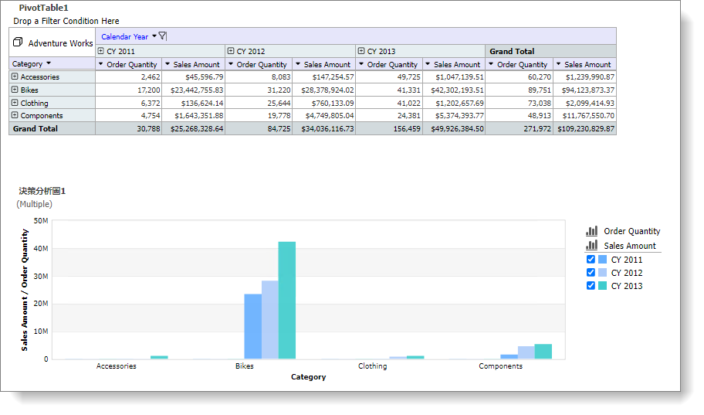  The Measure Settings option becomes active when there are multiple measures. Select "Categorize by Measure."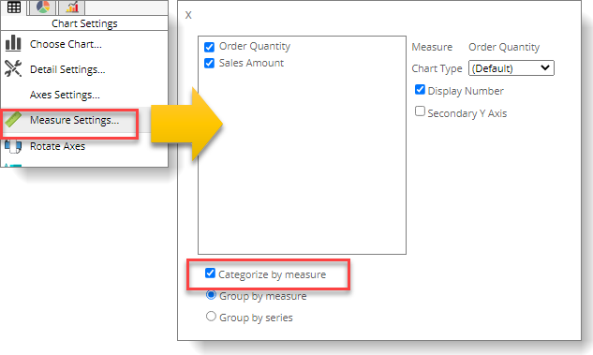  As a result, the measures become the Series, and the original axis members will become a drop-down menu in the upper left corner (as shown below).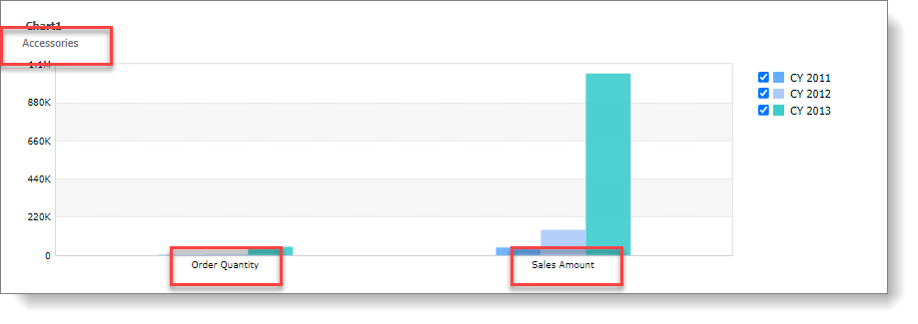
FS#4093 | Added default export settings for CSV in the Personal Settings". | Configure CSV export setting here will apply them as default options.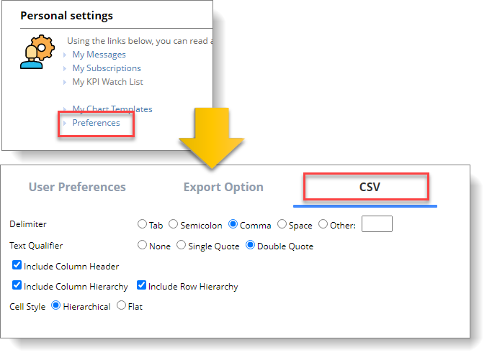
FS#4096 | Data Package 2.0 now supports the generation of a lunar calendar. | Provides users the ability to analyze the influence of traditional Lunar Holidays on sales data, which is useful for trend and growth analysis of the retail food industry in the Asian market, for example.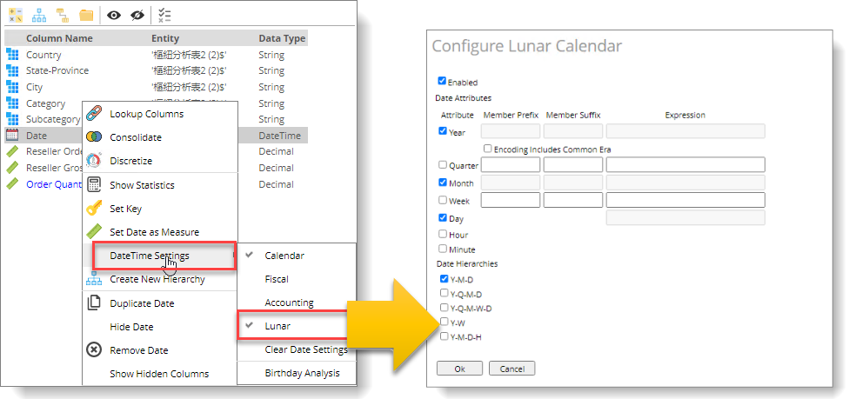
FS#4097 | Field Drop Zone | The pivot table's Field Drop Zone area provides users with a quick and convenient way to modify the pivot table structure such as Row, Column, Slicer, and Measure.  ⚫ In addition to adding and deleting structures, you can also use drag to change the order of objects.  ⚫ Two operation modes are supported - real-time or defer update. The table updates after the user clicks the Update button in the deferred mode.  ⚫ Each object has a menu to change its settings—set filter criteria directly in the Field Drop Zone for Slicer, Row, and Column.  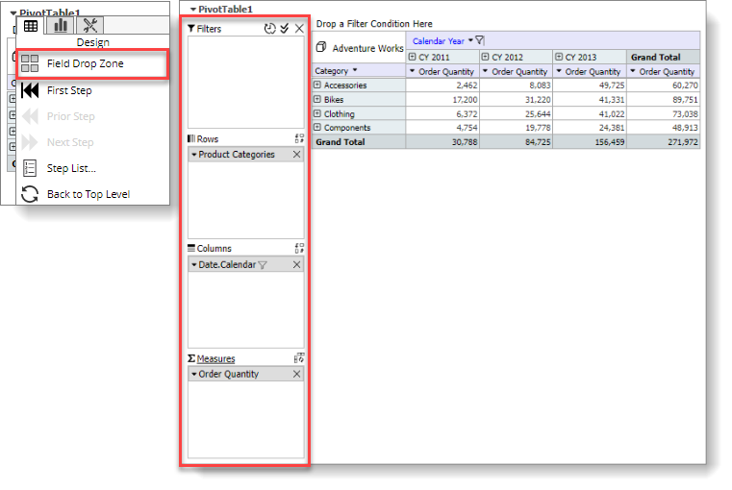  To use the defer function, please click the Defer button in the upper right hand corner. Drag the dimension, measure to the corresponding area, and click the "Update" button. The table will update accordingly.
FS#4111 | Cancel Query | An operation (opening a report or changing the filter criteria, for example) that takes more than 1 second now displays a work in progress dialog with a Cancel Query button. Use the Cancel Query button to stop the ongoing progress at any time. After stopping, the report will revert to the previous state or the top-level state if it is impossible to revert to the previous state.  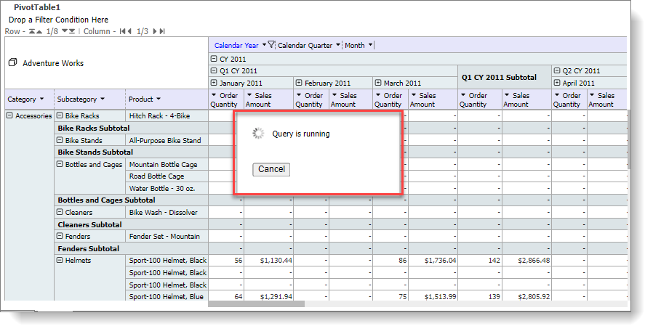
FS#4120 | Data Package 2.0 - Added date attributes associated with Constellation, Zodiac, and Age (birthday). | For date-type birthday fields, Data Package added new attributes for constellation, zodiac, age, etc., providing different ways to understand consumer spending based on different date-related aspects.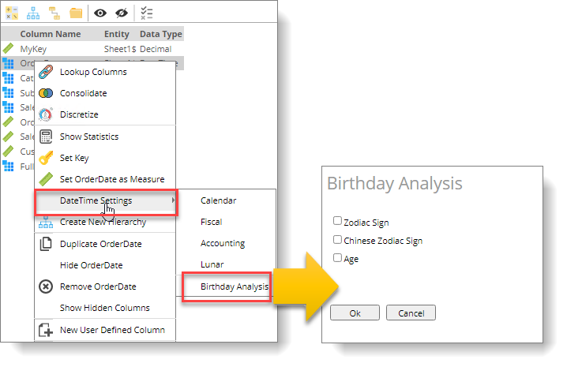
FS#4123 | New Waterfall Chart | The Waterfall Chart has the following features:  - Display customized colors according to positive and negative values.  - Ability to set values as negative (such as cost, expense) to facilitate the totality calculation.  - Display a total value after a Member. Calculate the total from the beginning or calculate the tally from the previous total.  - You can force a value to be the total.  - Ability to add a grand total at the end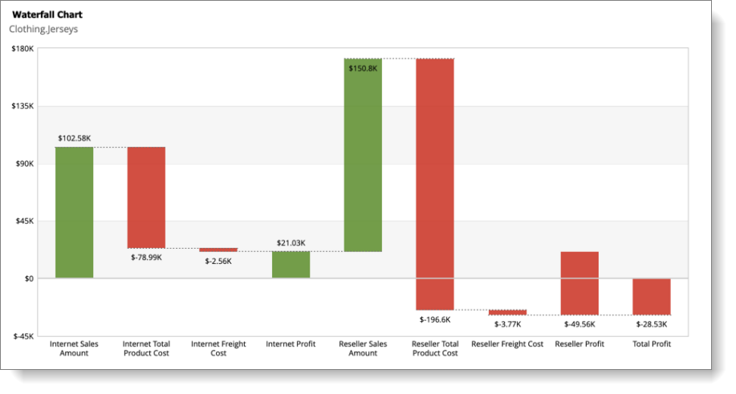
FS#4138 | Data Package 2.0-The Data Permission function adds data permission settings. | The Data Permission settings for a DataPackage adds the ability to add data level permissions. Use the "Allowed Member" and "Denied Member" to set permissions.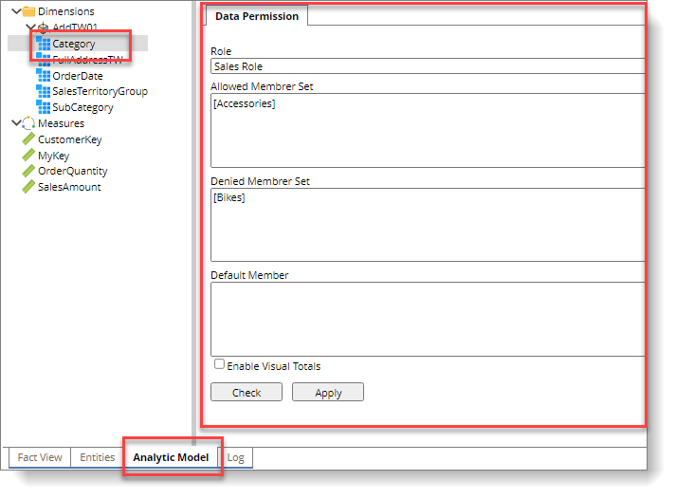
FS#4148 | Create Universal Charts directly from a pivot table. | Create and interact with Universal Chart directly from a pivot table. Access the Universal Charts under All Charts or individual chart categories.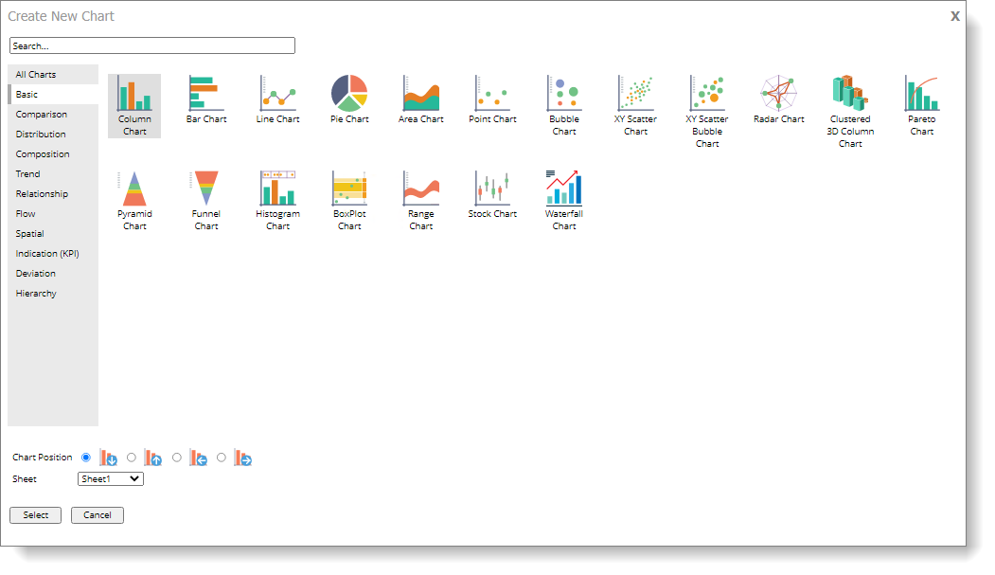  The example below shows the Text Gauges created from a pivot table. 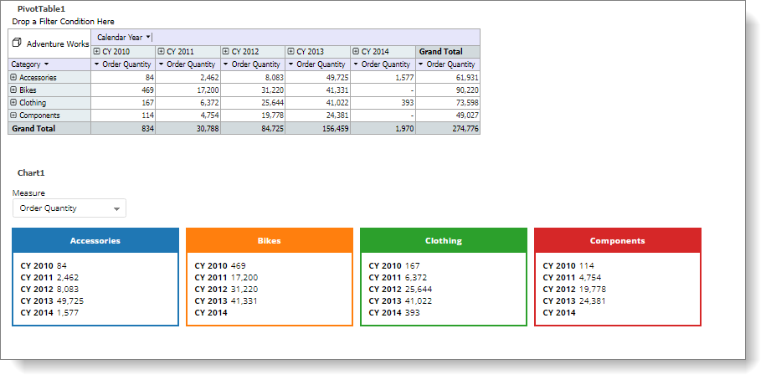
FS#4149 | Add BCG matrix chart | BCG Matrix divides the XY bubble distribution graph into four blocks. Each block has its special meaning. If the PivotTable has more than three measures, BCG will automatically take the first three in order and set them as X, Y, and Radius (as shown below)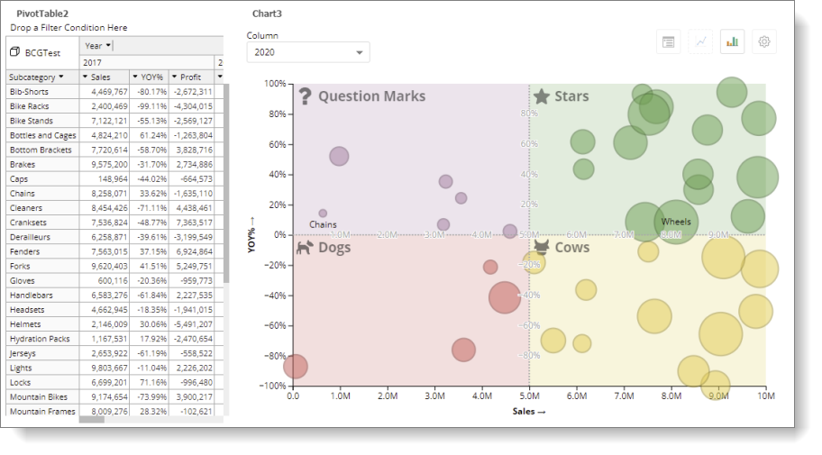  The four blocks of BCG can be dynamically adjusted by dragging or dragging the cross point to change both directions at the same time (double-click on divider or cross point will automatically bounce back to the default value)  - When adjusting, the current value will appear on the dividing line, so you can see what value the current position represents. The dividing line automatically snaps to the scale value to assist the user while dragging. The report saves the position of these dividing lines. If a new set of data does not work with the saved values, the lines return to their default position.  - The colors and labels of the four blocks can be set independently.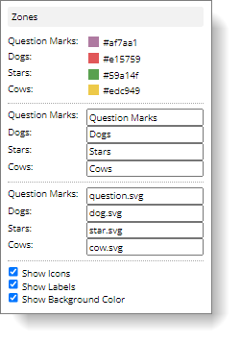  - The Highlight function can set the display range of various markers (Filter condition becomes invalid if there is no set Radius since each point has no size, however, this does not affect the label display)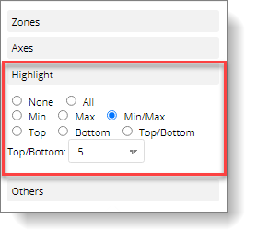  - A full range of axes settings can work with various data distribution situations. The default X and Y axis is Linear, which is suitable for normal conditions  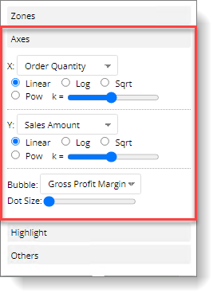  - Annotation setting determines to hide or show additional information when the user clicks on the bubble. Click on the same bubble or other white space to clear the annotation.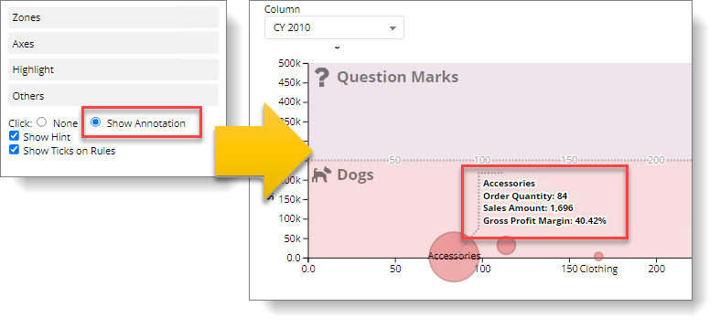
FS#4150 | Report Template | The report template allows users to quickly create various analysis reports through simple parameter settings, including ratio, year-over-year quarter-over-quarter, growth trend, performance evaluation, importance, correlation analysis, and so on. The template lets the user quickly generate a report from the Data Package or the existing Cube or apply further investigation to a cell or member using the template.  - Use templates in reports  You must select a Cube before using the template, as shown below.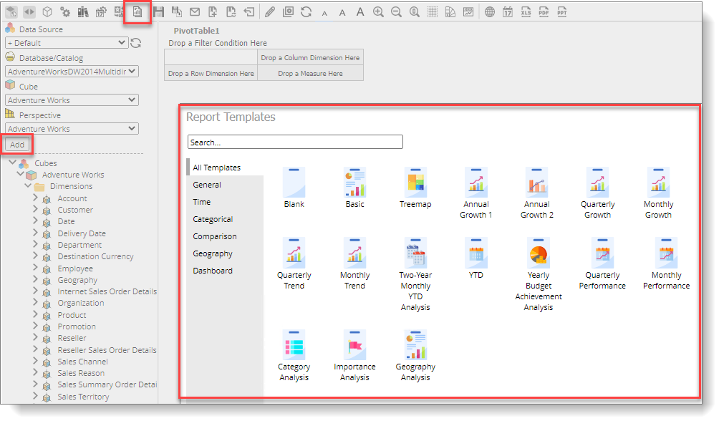  - Using templates in Data Package 2.0  After the data package is processed, you can use the template to create a report (as shown below)  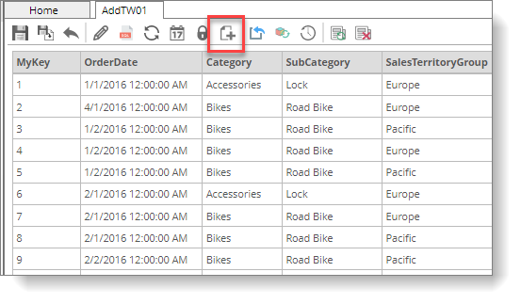  After selecting a template, a dialog for the selected template will appear. Enter all required parameters to create the template report.  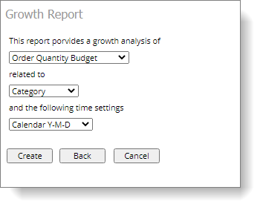
FS#4151 | Data Package 2.0 - Add the option of creating Tabular Mode Cube | In addition to creating a Multi-Dimensional cube, you can now create a Tabular cube using Data Packages 2.0. Other than the Member Property feature, which is not available to the Tabular Cube, all other features, including Time Intelligence, are available.  To create a Tabular Cube, please set the configuration as shown.  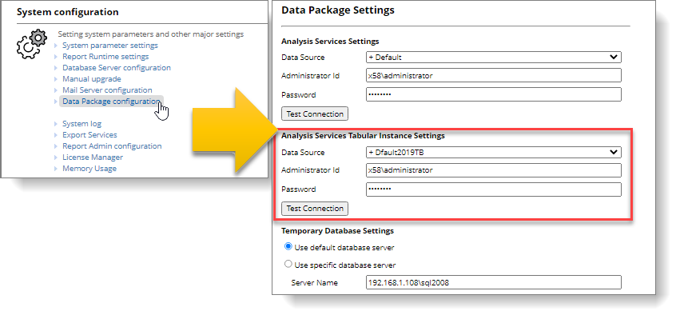  Select Tabular Cube as the type.  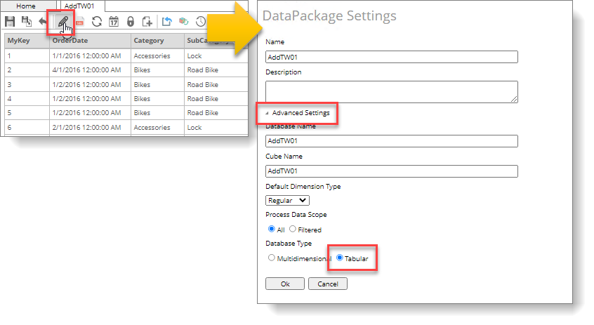
FS#4156 | New CSV Export API | We have added an ExportReportCSV() function specifically to handle CSV Exports in this version.  The existing Export API is for exporting the entire report. However, the CSV export is pivot table-based, one at a time. We also provide the ListReportComponentsCsv() function to identify the total number of components available to be exported as CSV.

Enhancement –10 Items
Item | Description | Comments
FS#4066 | Pivot Table – Subtotal First for Row and Column. | You can find the Subtotal First options in the Display Totals dialog box. 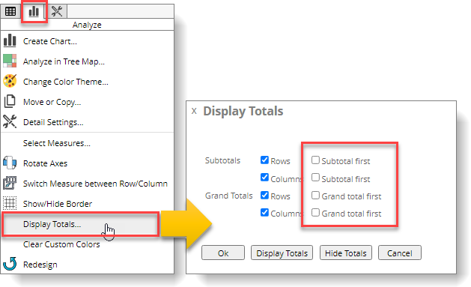  Result after applying the settings.  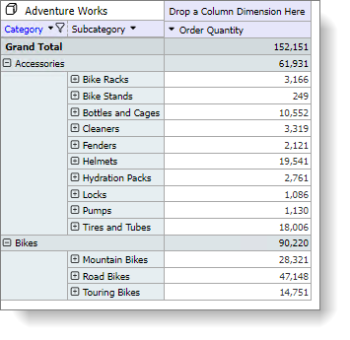  For comparison, this is how the table usually looks without Sub-Total First.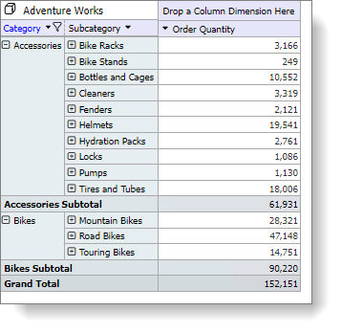
FS#4067 | Pivot Table – Grand Total First for Row and Column | You can find Grand-total First options in the Display Totals command. For an example, please refer to the description of the previous item (FS#4066).
FS#4068 | Pivot Table – Group by measure | The new Group by Measure mode groups the same Measure together for easy comparison under a member either on column or row. It works with Subtotal First and Grand Total First in conjunction.  Enable the "Group By Measure" option in the Pivot Table Detailed Settings, as shown in the figure below.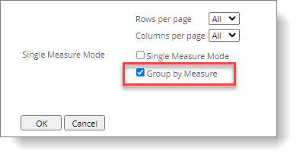  The result after applying the setting.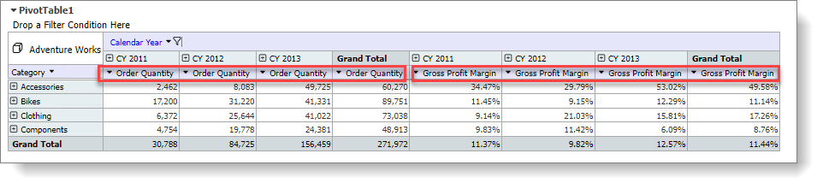
FS#4069 | PivotTable – Dimension Exclude Member | You can perform the Exclude Members function directly on the row and column members of a PivotTable with multiple selections. The PivotTable will automatically filter out the selected members. The user can go to Set Filter to edit the members filtered. The operation steps are as follows  Step1. First, select multiple members with Ctrl+left click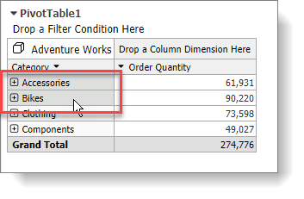  Step2. Click the right mouse button on the selected members to open the shortcut menu, and select Exclude Members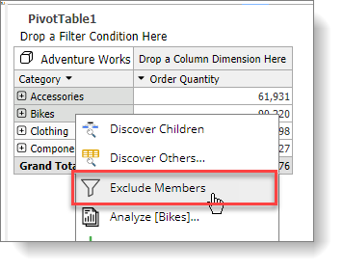  Step3. At this time, you can see the filter symbol appears on the header of the axis. Please click the filter icon.  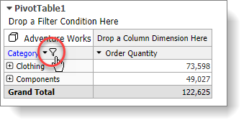  You can see that the system has automatically filtered out the [Accessories] and [Bikes] members  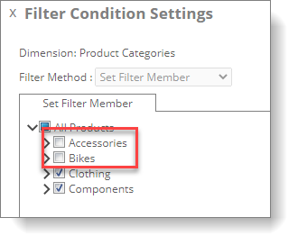  P.S. Executing Exclude Members again accumulates the filter criteria.
FS#4070 | PivotTable – Show Hidden Columns | Select the Show Hidden Column command under the Pivot Table menu to quickly bring back hidden columns. Hidden columns are shown as light grey.  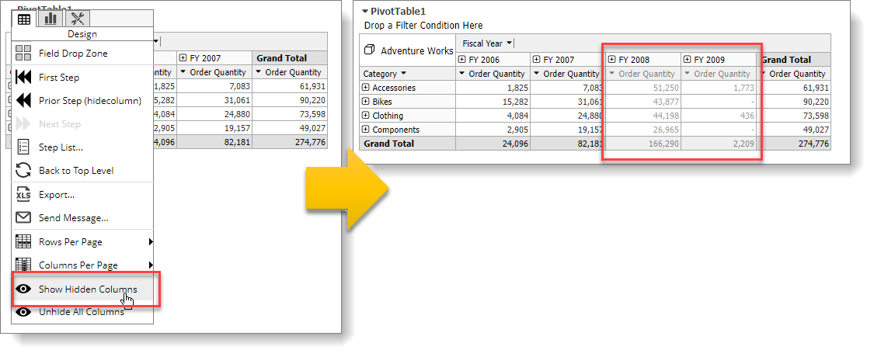
FS#4073 | PivotTable - Pivot Chart now supports Measure on Row. | Previously, a PivotTable could only draw a chart when the measure is on the column, but now it also works while the measures are on the row.  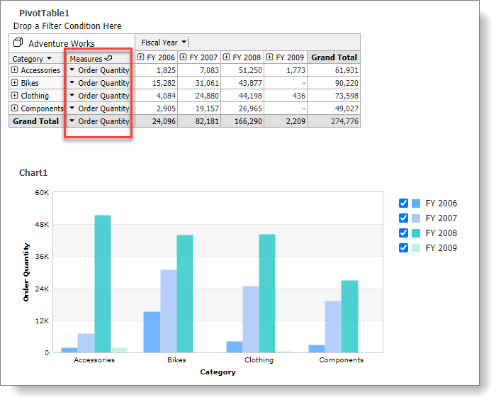
FS#4074 | Export CSV- column dimension provides "Flat" option | When exporting data to CSV, the column axis dimension will be filled with each level if you select the Flat option. Please check Include Row Hierarchy first to use the Flat option, as shown in the figure below.  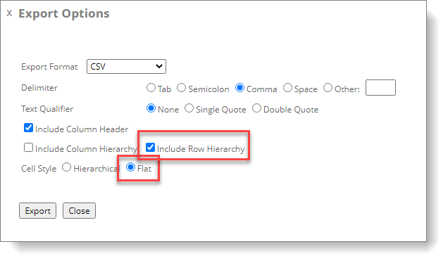  The hierarchical structure of column dimensions will not be indented when exporting, as shown in the figure below.  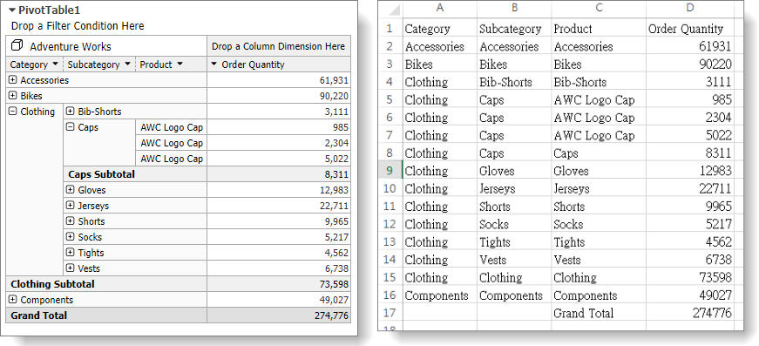
FS#4094 | Report - Increase performance while opening a report with a large number of member filter conditions. | In previous versions, when opening a report with filters containing a large number of members, the performance would be dramatically affected. This issue is now significantly improved in this version. In addition to updating Analyzer itself, please update the server with .NET Framework 4.8 and use the new Web.config file that comes with this version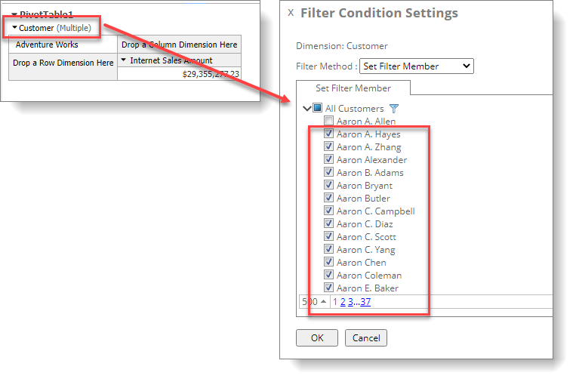
FS#4095 | PivotTable - Value Filter of Advanced Filter adds Base Column option. | In previous versions, the Advanced Filter -Value Filter could only be applied on the Grand Total values. With the Base Column option now added, a user can select a target column. As in the following example, to find the Category members in North America whose Gross Profit Margin is less than 10%,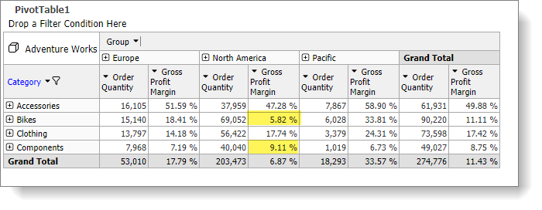  Set these settings  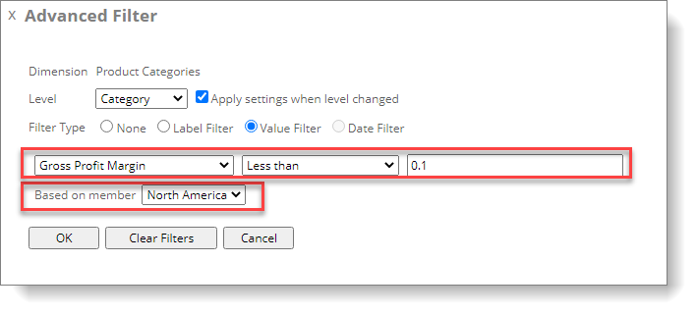  Result  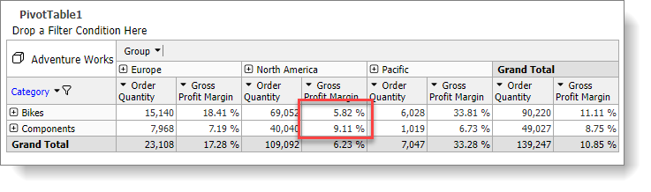
FS#4112 | Data Package 2.0 -Lookup Columns function added left-outer-join option | The Left-Outer-Join option prevents the loss of data in the Transaction Table due to an inability to find the corresponding lookup field values, causing the total to be incorrect.  For example, the [Category] column in the figure below is the lookup field.  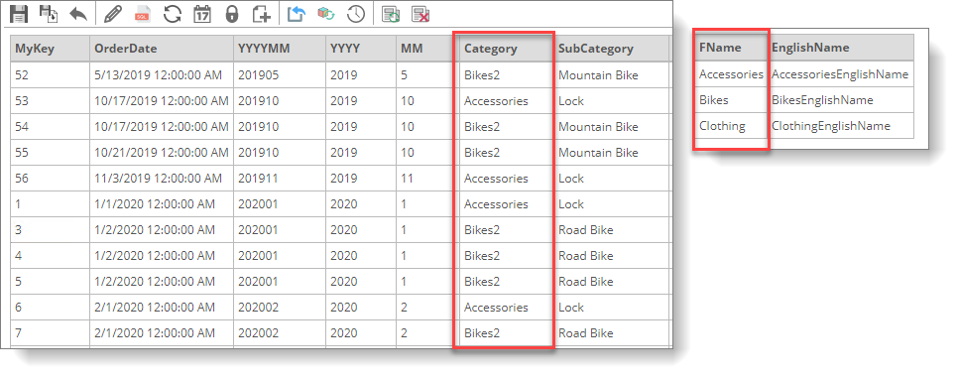  But because "Bikes2" has no corresponding data, without a Left-Outer-Join, the lookup result does not display all the data of Category="Bikes2". As shown below  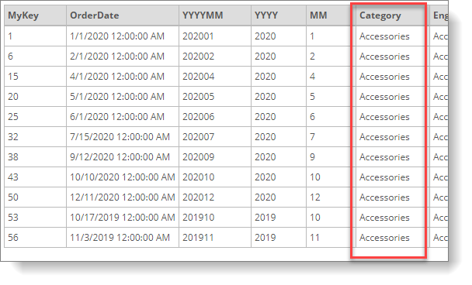  With this new Left-Outer-Join option, the data without a matching lookup results is included as shown below:  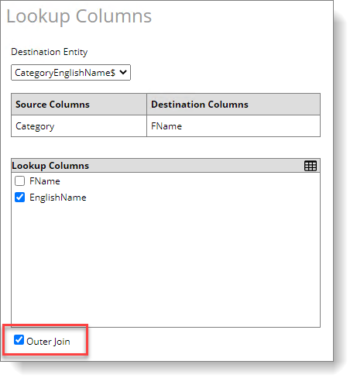  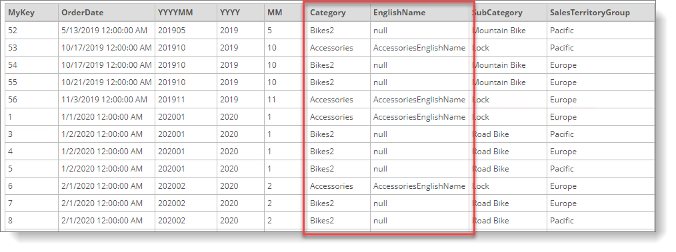
FS#4113 | Group Table - GroupItem can individually specify the Aggregation type. | The GroupItem of GroupTable adds the option of specifying an Aggregate type. In addition to the original Aggregate types, users can also choose different functions such as Sum, Count, Min, Max, DistinctCount, etc., which increases the usefulness of GroupItems. All GroupItems support this option, except for the Calculation GroupItem.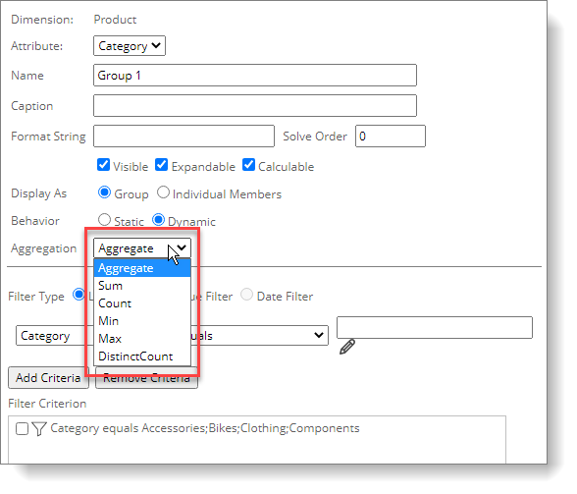  Example of Aggregation=Count  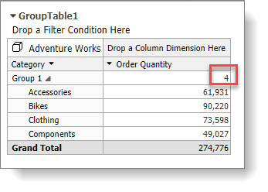
FS#4114 | PivotTable - Add column dimension member sorting option. | Now you can sort column dimension members in ascending or descending order according to the member name, for example, having the most recent period display first.  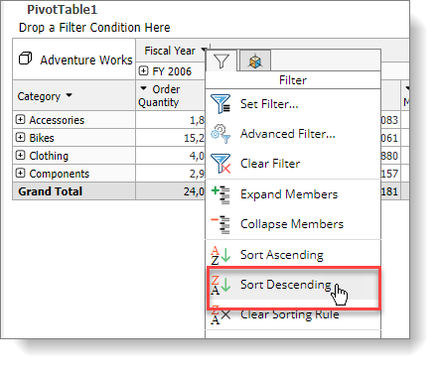  The result is as follows, you can see that there is a sort symbol on the column dimension name, and the first displayed column dimension member is [FY 2009].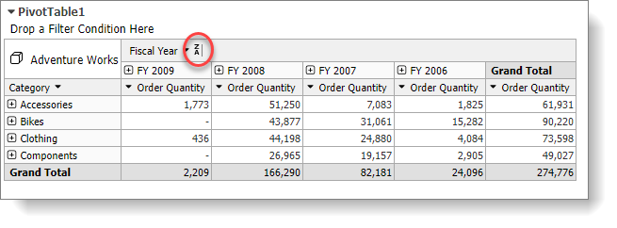
FS#4117 | PivotTable - Rearrange column dimension member display order | Users can customize the order of column members in a drag-and-drop manner. For example, the user can freely rearrange the order of countries. The previous version would only allow a user to customize the order of row axis members.  Right-click on a column member, then click "Rearrange Display Order." Using the list on the right, change the order of the members by dragging, and finally click "Rearrange Member Display Order" below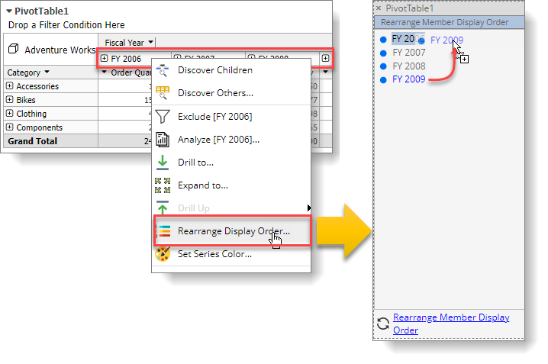
FS#4118 | PivotChart - Support pivot chart sorting by measure while there is no column or only one column dimension. | When a PivotTable has only one Column or no Column, the PivotChart now supports sorting independent of the pivot table. There is only one column dimension member on the PivotTable in the following example. On the left, the [Order Quantity] bar graph is set to an ascending order; the [Gross Profit] bar graph on the right is set to descending sorting.  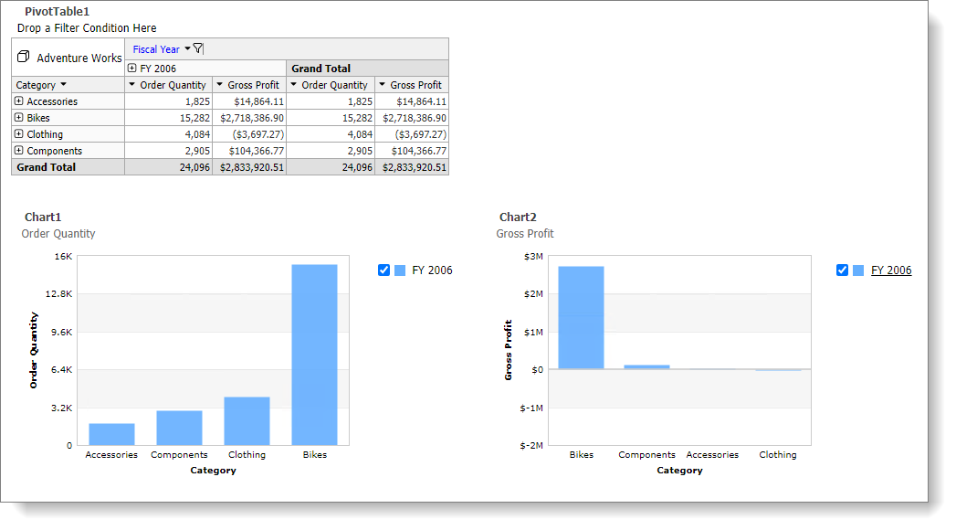  This chart option only appears when there is no column or a single column dimension.  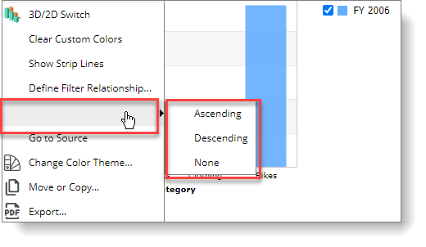
FS#4119 | Export - Export options adds the option of whether to include filter information when exporting | Sometimes you may not want to include the filter information in the exported report (for example, too many criteria or the criteria is already known by the viewer). The new option can exclude this information in the exported report. It supports both Excel or PDF format. You can also set this option as default in the User Preference and Report Properties. It is also configurable on individual subscriptions.  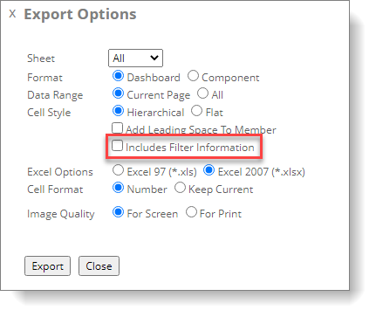
FS#4121 | Pivot Chart - The secondary Y-axis can support multiple values | In the Pivot Chart's Measure Settings, you can set multiple Measures to the second Y-axis. Previously it only supported one Measure.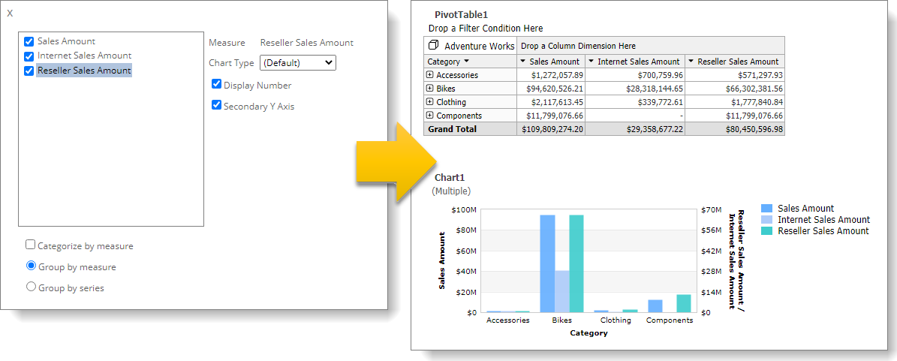
FS#4122 | PivotChart - Different colors can be used in a Pivot Chart while there is only one column dimension or no dimension. | A pivot chart without a column (or that has only one member) can now display chart members in different colors (previously only one color).  Select "Apply on single series" in the Chart Menu to use different colors for individual values in the chart. 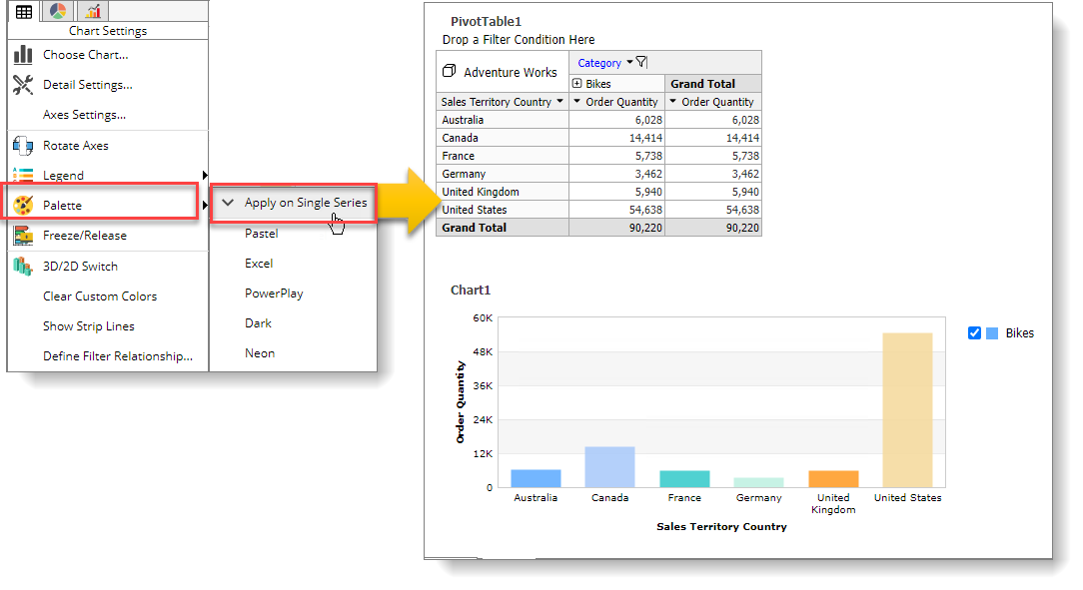
FS#4127 | Data Package 2.0 - Using a non-value field as a measure. | Previously, you could only use a value field as a measure. However, you can now also use a non-value field as a measure in this version with the Count() and DistinctCount() aggregation function. The example shows using DistinctCount on the Customer Name to see how many distinct customers buy individual products (avoid counting the same customer buying multiple times).  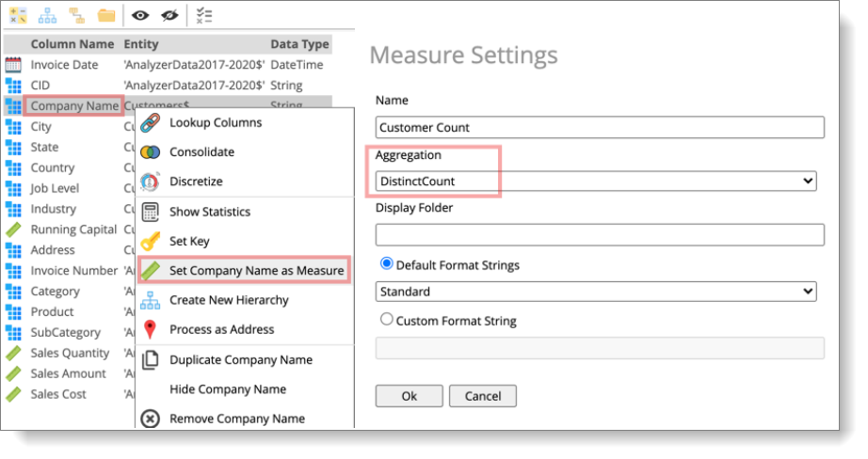
FS#4128 | PivotTable - Add a new AppSettings key to control Step-List items. | Initially, to prevent overloading the database server, the Pivot Table Step List (the Undo list) would disable after reaching a set threshold (when the selected members of the row, column, filter, and the slicer is greater than 100). The administrator can change this value by changing the AppSetting key below or setting it to -1 to have no limit.  <add key="StepListDisableOn" value="100"/>
FS#4130 | Data Package 2.0 - Add Semester level to the Time Dimension. | This version adds the option of Semester for Calendar, Fiscal Calendar, and Accounting Calendar. Now it is possible to generate Semester and Semester of Year attributes for the calendars mentioned above that automatically establish the Hierarchy of Y-H-Q-M-D, which is very convenient for analyzing semi-annual reports.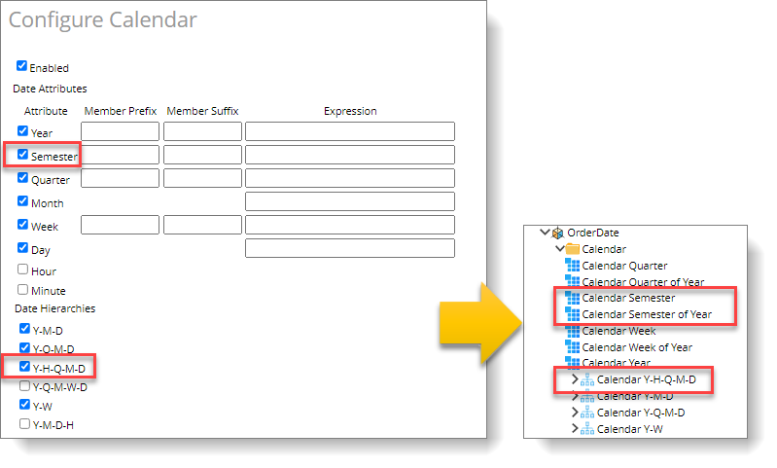
FS#4131 | Group Table - Group Items can be expanded to unlimited levels | As long as there are no infinite loops (for example, a child of a Group Item is also the parent of the Group Item), the Group Table now allows Group Items to expand to multiple levels (previously limited to the second level only).  In addition, the indentation of group items provides three options: Large, Medium, and Small.  At the same time, the function of expanding groups has been added, which is convenient for users to expand the Group Table to the Nth level at the same time.  To establish a multi-level structure in the following example, please start with the lowest level, such as [g8000], [g8100]...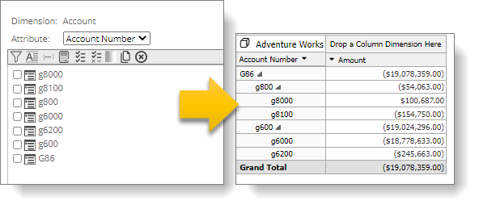  Then refer to the item of the next layer in the Calculation group item, as shown in the figure below,  [g800] quoted two sub-items, [g8000] and [g8100].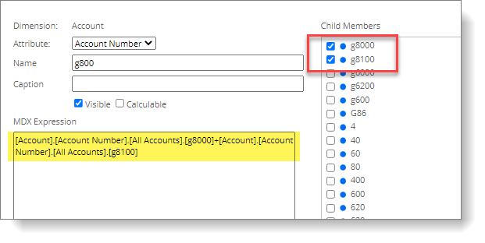
FS#4132 | PivotChart - Row, and Column add Data Series for SubTotal and Grand Total. | In the Detail Settings of a PivotChart, add new options to show SubTotal and Grand Total. In this version, the user can display the Data Series of SubTotal and Grand Total, which adds flexibility to the graphic presentation.  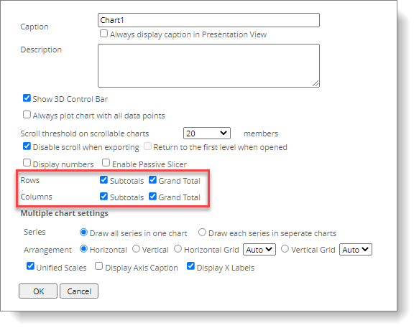  Because the row and column axis Grand Total are checked, the Grand Total item appears in both the x-axis and Legend of the graph.  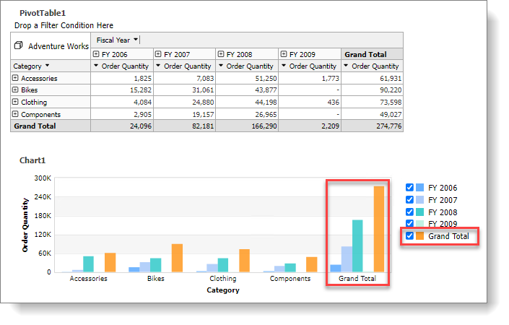
FS#4133 | PivotChart - Added support for Multiple Charts | Too many data series sometimes make a chart difficult to read and compare. Use the Multiple Chart Settings to present different Data Series as individual Charts. As shown in the figure below, instead of drawing all Data Series in a single chart, the new option draws each Series as a separate chart. Select the Unified Scales to have all charts with the same scale for easy comparison.  To enable the Multiple Chart mode: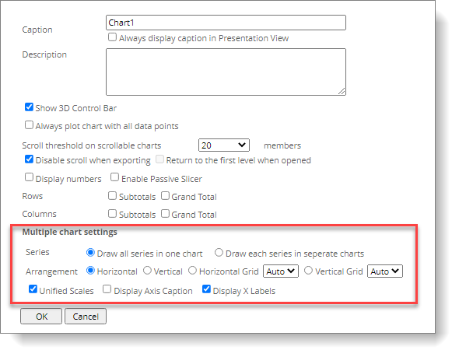  Below are the same charts with and without the MultipleCharts option.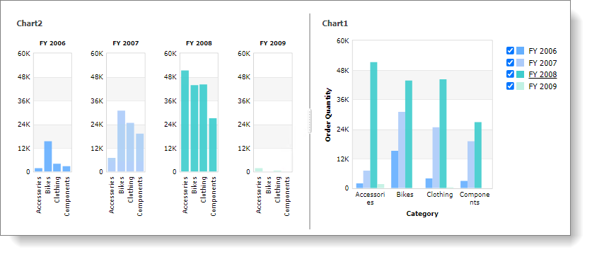
FS#4136 | Group Table - Member Property adds the option of automatic display or not | The Member Property can be used to increase a GroupTable's readability, for example, showing Subject Title member property associated with the Accounting Code attribute. However, if the table has not yet expanded to the correct level in the previous version, a blank member property column is shown.  The member property column is hidden in this version until expansion reaches the correct level. In the example below, the left side shows the result of the new change, and the right side shows the old result.
FS#4141 | PivotChart - When multiple Measures are displayed, it is now possible to use different colors for the values if only a single legend member is selected. | When a pivot chart has multiple Measures but only uses a single member on the legend, previously, the Chart would use the same color for both Measures, making the graph difficult to read. Selecting the Apply on Single Series option can now solve this issue. The left is the old result, and the right is the new result.  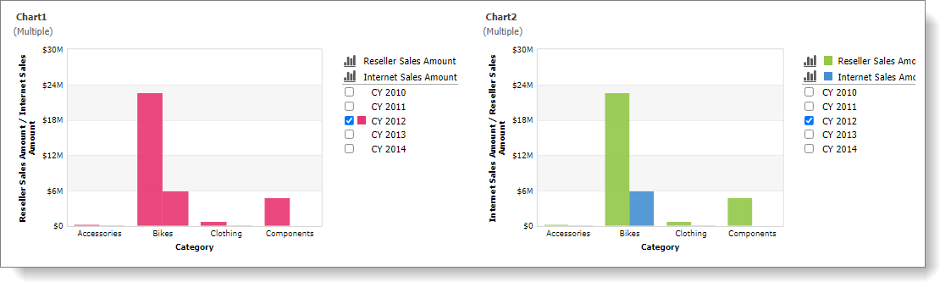  Select the Apply on Single Series option from the Palette sub-menu.  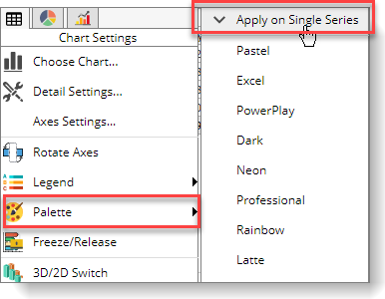

Bug – 17 Items
Item | Description | Comments
FS#3268 | PivotTable miscalculates the number of pages with hidden totals. | Fix the following issues:  When the data (including subtotal) exceeds by 1 per page, and the subtotal is hidden, the last record will be missing.  The following example,  [Category] Filter out [Clothing]  [Style] only displays [Not Applicable] and [Womens]  50 items per page  Hide the subtotal, and you will get the following result.  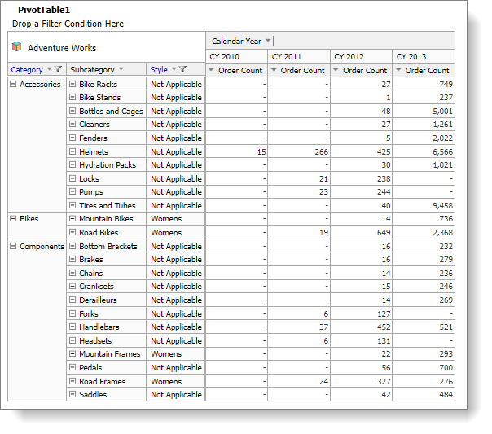  After the correction, as shown in the figure below. You now see the [Wheels] member on the second page.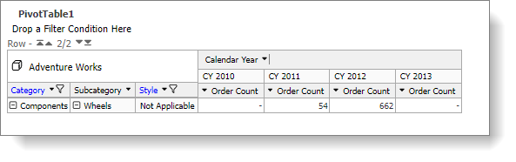
F#4063 | "Report Auto Scaling" should be the default setting for new reports, but the settings are not applied when adding new reports. | Fix the following issues:  When adding a report after checking the system parameter "Report Auto Scaling," the setting is not applied to the new report.  After the correction, the global setting on the left appears locally in a new report.  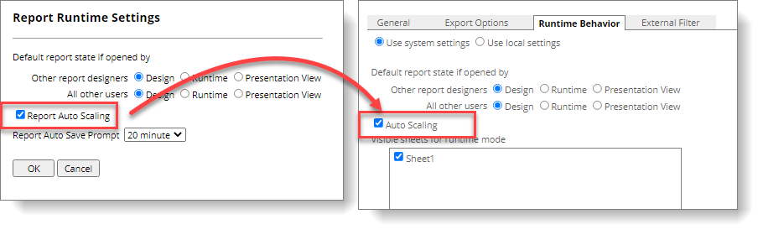
F#4060 | When exporting a Tree Map to Excel, the top row of words is obscured | Fix the following issues:  When exporting from TreeMap to Excel, the top row of words is obscured.  The figure below shows that the left side is before correction, and the right side is after the correction.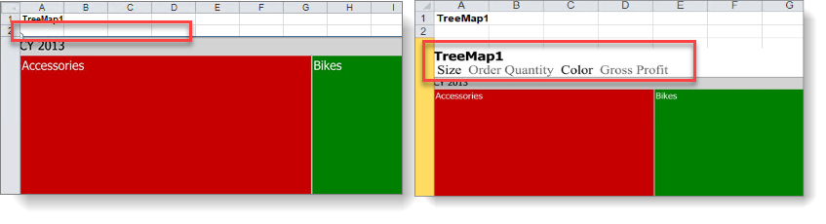
F#4059 | When Pivot contains Member Property, export CSV and checks Row Hierarchy, the result is incorrect | Fix the following issues:  When PivotTable contains Member Property, export CSV with Row Hierarchy checked, the result is incorrect. For example, here is a table with the Class and Color member properties.  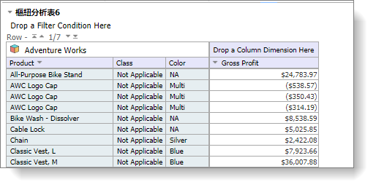  When exported to the CSV file, it shows duplicate columns (incorrect).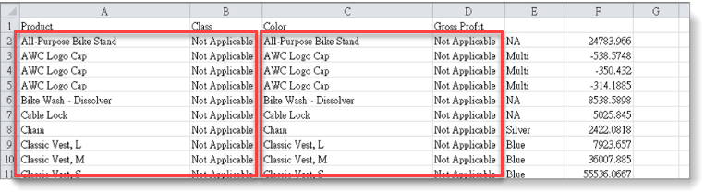
F#4056 | Export to CSV with Flat option, while measures are on row, produced incorrect results. | Fix the following issues:  While Measures are on the row Axis with the dimensions expanded (as shown in the figure below). Exporting to CSV with the Flat option produces an incorrect result.  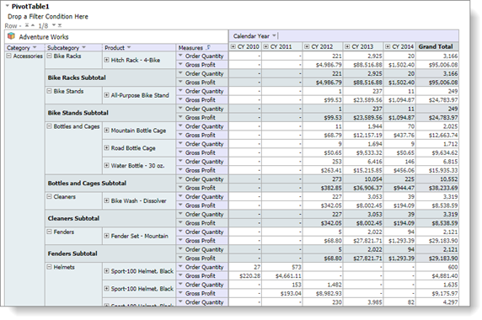  The incorrect result is on the left—the correct result on the right.  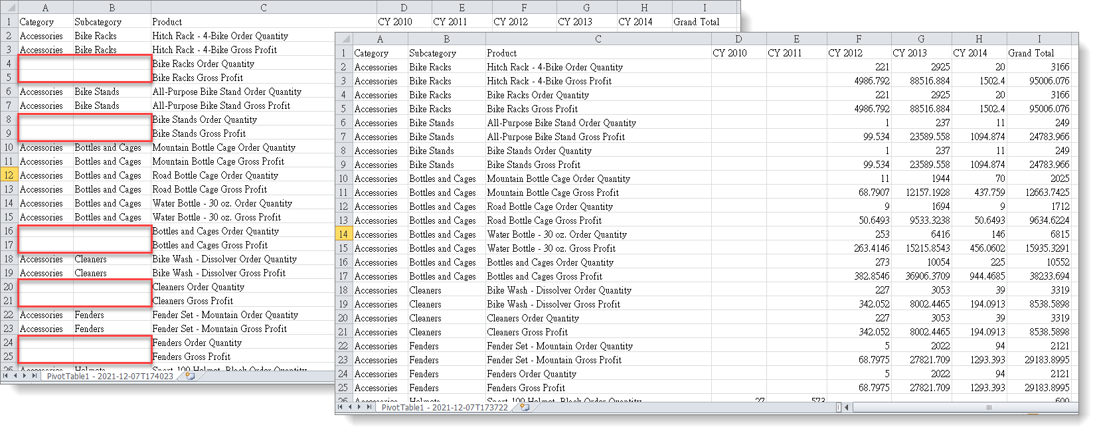
FS#4092 | Unable to use Visualization function while the Measures are on the row. | Fix the following issues:  The Visualization feature does not work on the second and subsequent Measures while the Measures are on the row axis. The left of the figure below is before the correction, and the right is after the modification.